(Approx. 866 words)

Wireless Router Setup
By Bob Elgines, Editor, Colorado River Computer Club, Arizona
www.crccaz.com/
elginesz@rraz.net

Obtained from APCUG with the author's permission for publication by APCUG member groups.

How to change the setup or configuration of your Wireless Router and PC. First we need to get to your router after the original setup by bringing up Internet Explorer on your direct wired computer (Master) and typing in one of the code addresses below:

TYPE CODE USER PASSWORD CHNL
Belkin: 192.168.2.1 (No Name) (Leave Blank) 6
D-Link: 192.168.0.1 admin (Leave Blank) 6
Linksys: 192.168.1.1 (Leave Blank) admin 11
Netgear: 192.168.0.1 admin password 10

A login screen will appear, if you used your own login name and password then use them. If you lost them and you wish to reconfigure your router you will have to push the reset button for at least 30 seconds. This sets the router back to its defaults and you can use the default values above.

During your setup you may have seen “Number of DHCP users allowed”, reduce this to the number of total computers in your network or that number plus one.

SSID is your wireless network name, for example, Linksys will broadcast “linksys”. First, we want to rename your SSID and then hide it later. After changing the name, we need to reconnect with each wireless computer. To reconnect, right click the icon in the System Tray (or task bar-right).

Windows XP SP2 - Choose Available Wireless Networks / Change Advanced Settings. Click the Wireless Networks tab, click Add button in the Preferred Network section.
Type in the Network name you have chosen, then click OK twice.

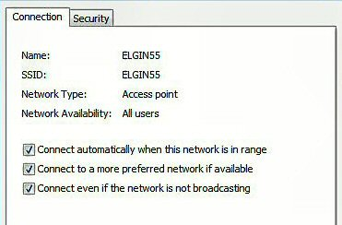
Windows VISTA - Select Network and Sharing Center, then left click on View Status (located middle-right). Click on Wireless Properties button. Put check mark on “connect even if the Network is not broadcasting”.

(Or go to START / CONNECT TO / click on your SSID and click the CONNECT button below. Then you can right click on your SSID and select Properties. This will get you to your Wireless Properties window where you can put the “check mark” and enter your Security code.)

Complete this on all of your wireless computers and remember how you got there!

Second, now we can choose to stop your Router from broadcasting your SSID by selecting disable to “SSID Broadcasting” in your router setup. All your computers should be reading the wireless connection.

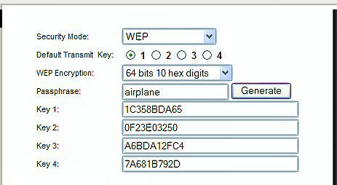
Next step is to select a Security type, let us try WEP first. This may be slightly different due to different manufactures. Usually you will find it under Security or Wireless tabs of your router setup. Select 64 or 128 bit encryption, then type in a word or phase and let the router do the coding by clicking on Generate. Select #1 and write down this code for your wireless computers. Go to the Wireless Properties window and click on the SECURITY tab. Then set the ENCRYPTION type to WEP and enter the security code you wrote down, click OK and Close. Key Index should remain on one.

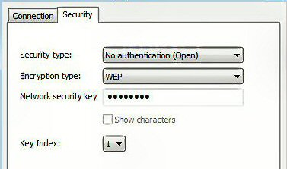
Look at the Security Type by clicking the down arrow on the right. Note these are the other types of security allowed: WPA2-Personal, WPA-Personal, WPA2-Enterprise, and WPA-Enterprise. Most newer routers and computer can operate with this type of security and is considered better than WEP.

We completed a simple setup to supply a secured wireless connection. You can go further and use one of the WPAs if all of your computers will accept this. Just disable WEP and enable WPA and roughly go through the same process. You could also assign your MAC addresses, but how far do we have to go?

Following are definitions for MAC, DMZ, WPA, DHCP, and the router FIREWALL:

DHCP – Dynamic Host Configuration Protocol as a server assigns IP addresses to all computers on the network (in this case the router is the DHCP server).
DMZ – Dedicated Multi Zone exposes a computer directly to the internet with a IP address. Some games require this direct access. You could give a false address not used by your computers to send intruders to an address that goes no where!
FIREWALL – The router’s firewall gives protection on data coming in, but not going out. If you wish full bi-directional protection you will have to use software and replace your windows firewall which is incoming only.
MAC – Media Access Control is a number related to the network adapter in a small network. LAN-MAC address is for your internal network and WAN-MAC address is used for router to modem connection. You can find your Client table (IP and MAC addresses) in your router’s configuration utility.
WEP – Wifi Encryption Protection is the old security standard that can be used with either 64 or 128 bit encryption.
WPA – Wifi Protected Access is the latest network security standard, but if your equipment is over two years old you may want to checkout www.wi-fi.org web site for information. For full instructions on activating WPA see PC Magazine’s step by step article at http://www.pcmag.com/article2/0,1759,1819544,00.asp

This article has been provided to APCUG by the author solely for publication by APCUG member groups. All other uses require the permission of the author (see e-mail address above).

